Supplementary Information

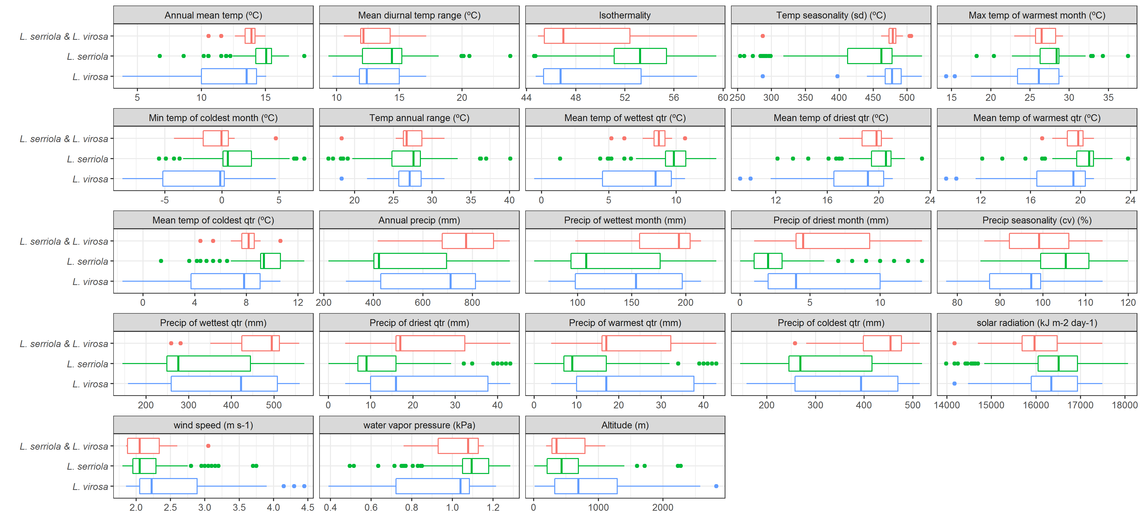
Supplementary Figure 1: Climatic and topographic characterization of sites where L. serriola, L. virosa, and both species were found. The thick vertical line represents median values across occurrences, the boxplots between 25 and 75% of variation, and circles the outliers within 90% of total variation.

A
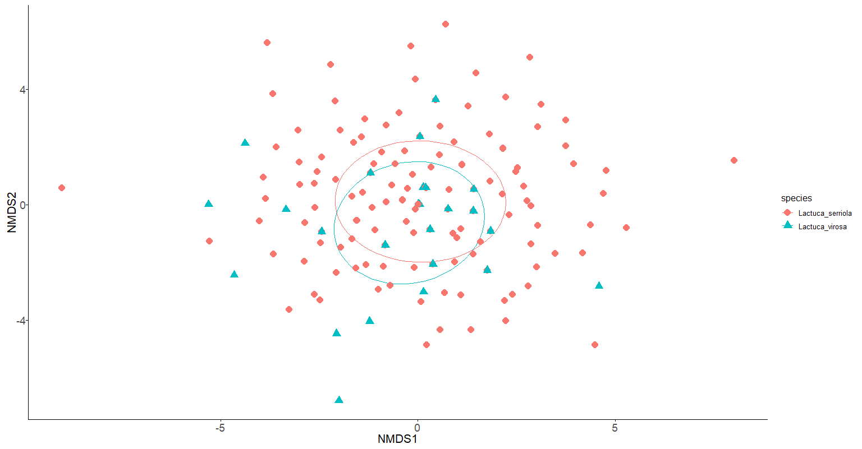

B
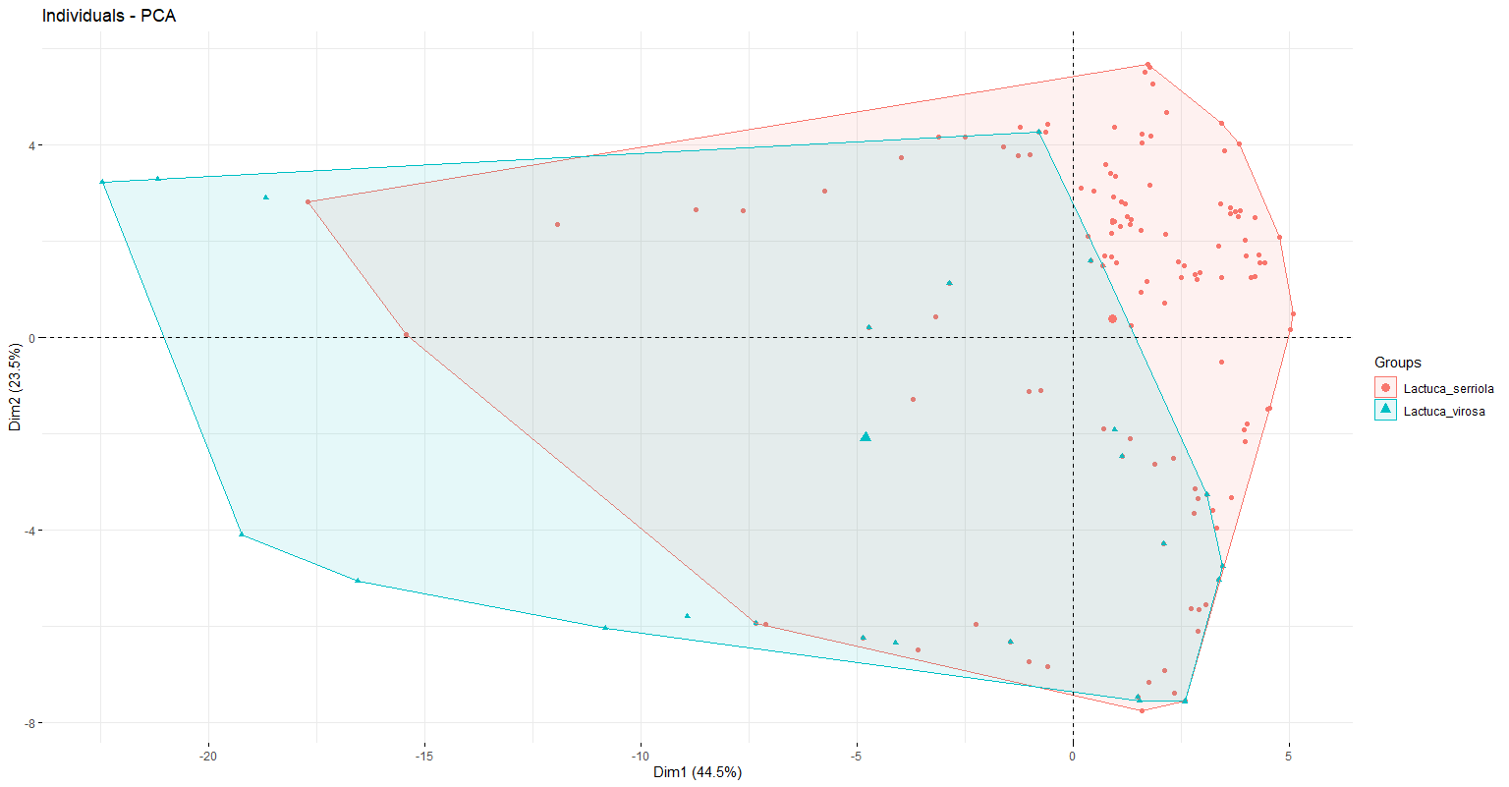

C
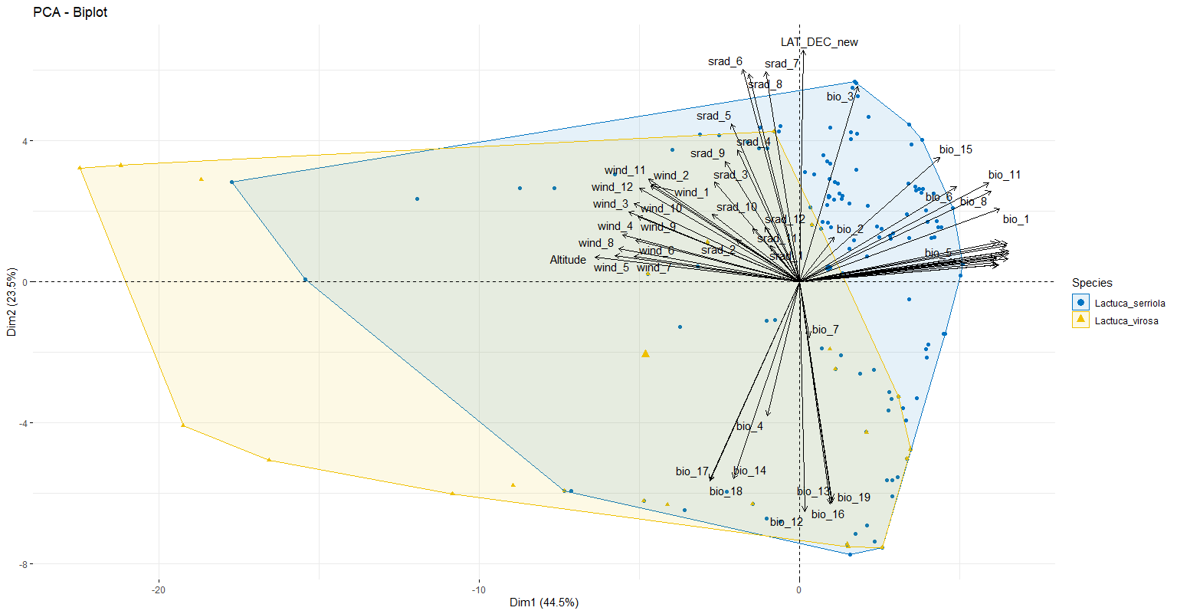
Supplementary Figure 2: A. Non-metric multidimensional scaling, B. principal component analysis, and C Biplot of principal component analysis, showing the 23 measured climatic and topographic variables, for L. serriola and L. virosa. Sites where the species overlap are not included in these analyses.

